YALE AVIATION NEWSLETTER
August 15 2018
UPCOMING EVENTS –
- KGBR (Great Barrington) 8th Annual Fly-In – Saturday Aug 18, 8:30 am to 4 pm (Pancake breakfast from 8-11 am). Short field takeoff and landing (STOL) demo, airplane, helicopter, balloon rides, live music, farm & food vendors.
- Mory’s Event – Thursday Aug 23, 6pm. We will gather at the Temple Bar before hearing air show operations maven Gerry O’Neill, who has managed operations at many of the major air shows in the United States over the last 20 years. He got his start with us at the Tweed Air Fest in 1991 (and was also a private student of John DeCarlo!) He has about 1 million good pictures of his work at airshows, and we might even convince him to talk about his visit and stay on the USS Nimitz aircraft carrier. For more information, contact John DeCarlo, JDeCarlo@newhaven.edu
- GPS Scenario Workshop, Sept 8/9, 3pm – ROTC Hangar (where the simulator is). Try your hand at getting to KBID using our new Garmin for guidance. Jake White will lead you through using the Garmin Trainer app on your iPad to practice enter and altering flight plans, and entering frequencies. RSVP Jake White with your preferred date! Jake.white+ya@yale.edu .
- Simulator Open House, Saturday, Sept 22 – Take our virtual airplane for a spin, rain or shine!
- 33rd Annual Simsbury Fly-In, Car Show & Food Truck Festival – Sunday, Sept 23, 10 am to 5 pm, Simbury Airport.

- Wash & Wax, Saturday, October 27, 9 am to noon – Help us decrease drag ad increase ramp appeal for our two aircraft. Save the date!!

PILOTS…

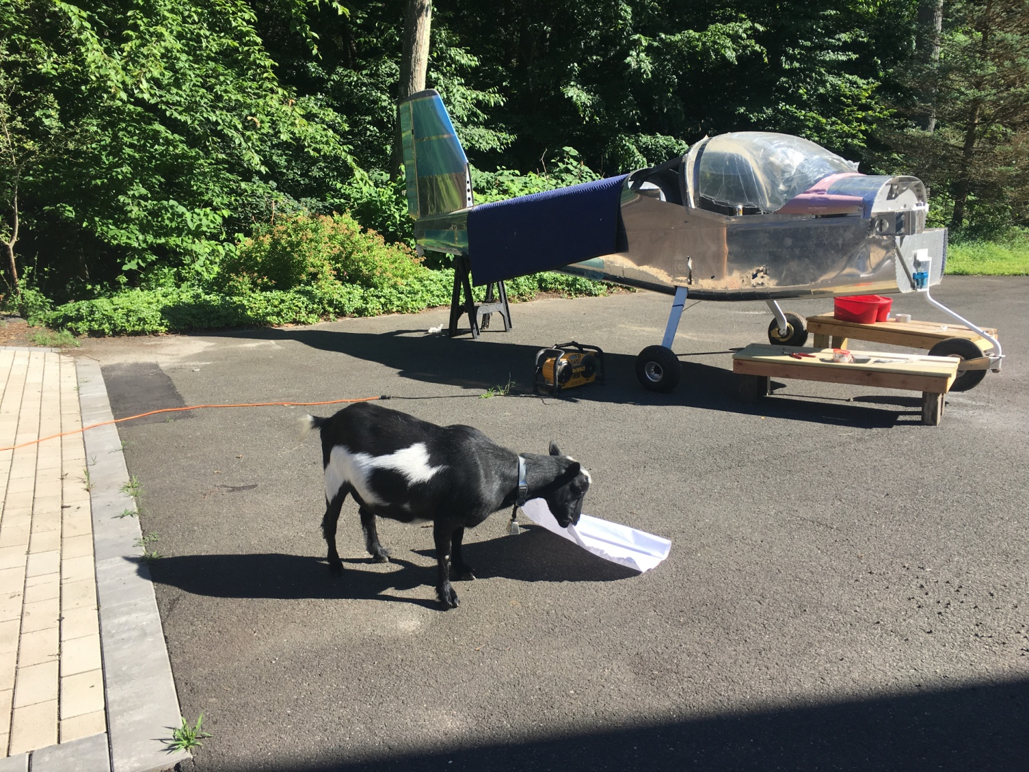
Bon voyage to Alark Saxena, who is moving to Singapore, where he swears he will be finishing his private pilot…
Mr. Pickles, Donnie Mac's goat, absconded with the plans for the RV-12 and quickly consumed them. (Paper is by far his favorite snack.) Fortunately there was a spare copy, either that or the tail may fall off, we shall see. Anyone wishing to stop by an visit Donnie’s aluminum mistress, just drop him a line, email is always good. [He went to OshKosh in search of a power plant!]

Although not a YA member, Dan (the Robinson lineguy) was seen showing off his new Aero-Commander 112 which he recently purchased with a partner. 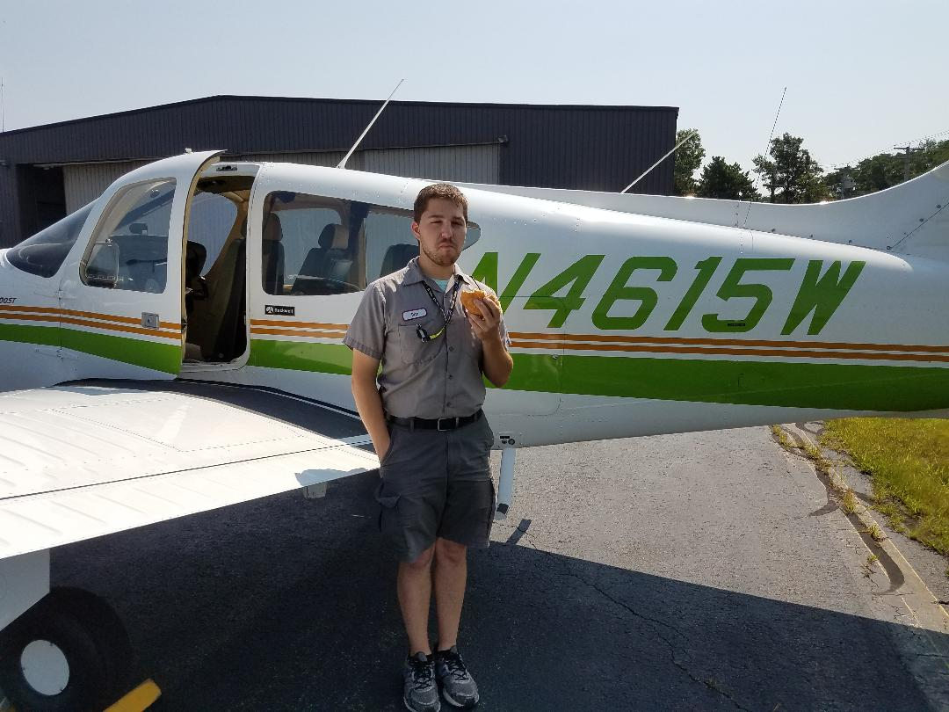

Those of you who’ve accumulated more hours than you might likely fly please consider donating to the club – it is tax deductible!! Help keep Yale Aviation alive in the future as it was for you!

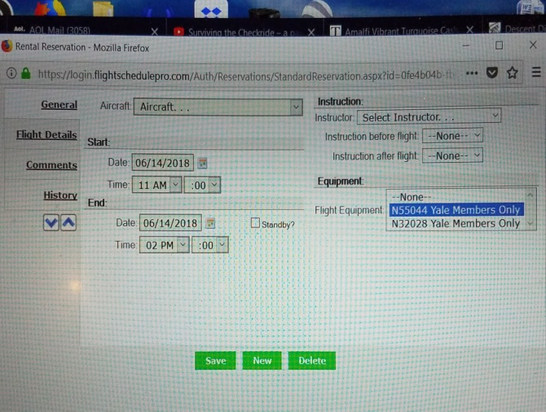
… & PLANES
It’s flying weather! There are a couple of things you can do to help keep our airplanes flying and fellow members happy:
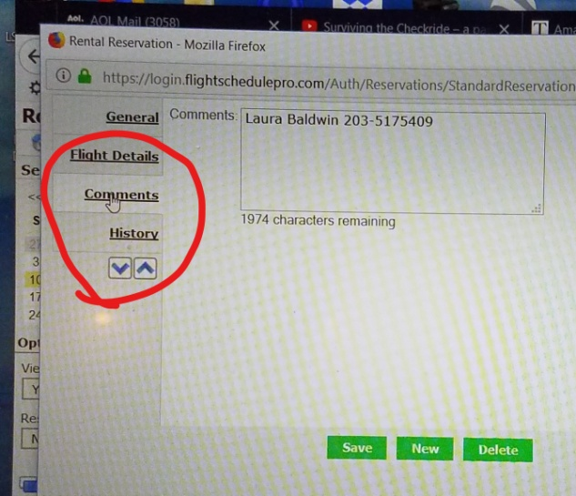
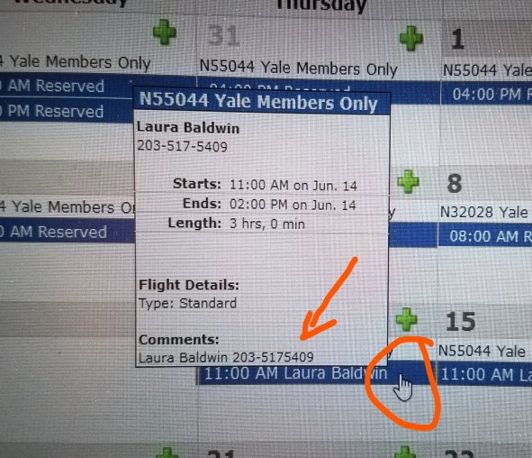
  - Consider including your name and cell number in the “Comments” tab of your reservation form (see photos below). The tabs are located down the left side of the form. The information from the Comments tab can be seen when you hover your cursor over the reservation.

  - Be sure to cancel, especially due to weather, as soon as you can. Some of our members can make use of the marginal weather you may not be comfortable with, but they won’t know the airplane has become free unless you cancel!
  - Of course, letting Charlie know if you are running late on a reservation, or want to cancel after your start time, is always an option.
  - Last but not least, we are interested in developing a dynamic list of those who are interested & available to fly with a fellow member. Often this can be beneficial for both parties. Email Laura Baldwin (lfbaldwin@aol.com ) with your interest and general availability.
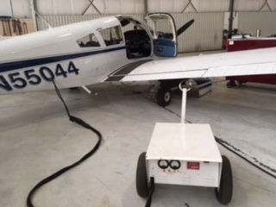
ADS-B IN OUR AIRPLANES
N55044 received its ADS-B in January, and members are beginning to fly using this new equipment. Those flying 55044 need to get additional training to become practiced in using the new GTN650, especially before IFR flight!
For VFR flight: You will need some basic training, which can be given by a YA CFI during a 90-day, Flight Review or basic YA checkout. We trust that our members will use good judgment to be sure they are adequately familiar with this new technology for simple VFR flying.
For IFR flight: We will be requiring a sign-off by one of our YA CFIs to ensure that all the ins & outs of flight planning, approach loading, and validity of use of the GPS as a navigational tool are practiced and understood.
In addition, Robinson has an external power source one can use to power up our GTN for practice BUT YOU MUST CONTACT Charlie Skelton to do this! We have manuals and reference guides on our website, and plan on formulating a syllabus for both VFR and IFR use of this equipment. The checklist for 55044 is also being updated to include checks that should be made as the GPS unit powers up.
Any comments or questions, please contact Jake White, Laura Baldwin, or Akihiro Hashimoto.

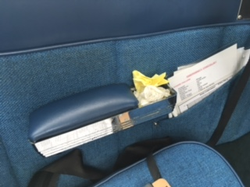
HOW WE TREAT OUR AIRPLANES! When you arrive at the airport, you should expect the aircraft to be in good condition. Remember:
    - TAKE OUT THE TRASH! Please be sure any spare paper, charts, etc are removed after your flight.
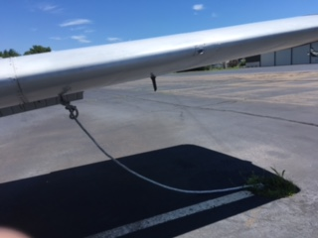
    - CAREFUL WITH THE BRAKES!! We have had 5 tire changes in the last year, with “flat spots” often seen on the tires of both airplanes. This is most commonly caused by landing while holding the brakes or braking too hard to make the first turn off the runway. PLEASE, be kind to the tires, and watch how you are using the brakes.
    - Tied down securely, with proper knots, taut lines, and no spare length of rope that can whip around in the wind. The picture below is NOT acceptable tie-down!!!! Please ask if you need a demo or some practice in this vital area for airplane security.
    - Gust lock is in position, window closed, aircraft locked (both baggage compartment AND door), COVER ON!
    - ALL instruments turned off –particularly important for doing the hot mag check at shut-down, since an unexpected electrical surge could fry delicate avionics equipment left on!
If the aircraft is not up to this standard, please let chief pilot Charlie Skelton (203-640-3580) know so he can improve matters. Be sure to leave our airplanes secure and clean – just like YOU would like to find them!

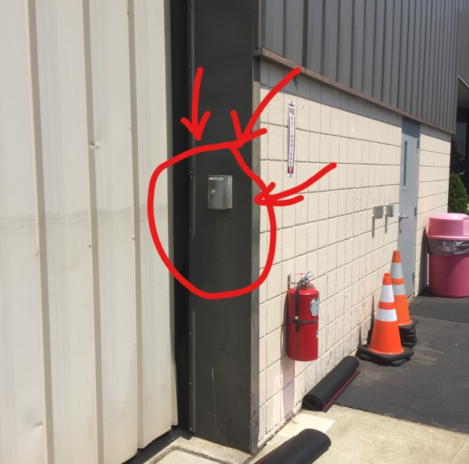
We like to encourage our members to take the airplanes and make use of them, but PLEASE remember that if you find you need to have fuel for the planes or take them in or out of the hangars afterhours, this will result in a CALLOUT FEE of $150 that will be charged to Yale Aviation and passed on to you. The easiest way to avoid these fees – and work well with the kind line folks at Robinson – is FOR YOU to let the Robinson front desk know well ahead of time if you need fuel or wish to use the airplanes early or late. Please be as considerate as you can of their time and efforts.
In addition, there is a drop box to the right of the doors to the hangar nearest the FBO entrance from the ramp. This is where you can leave airplane keys if you return to the airport after Robinson has closed. PLEASE be considerate of your fellow aviators.
Any questions? Please give Charlie Skelton a call and he can go over both dropbox use and what constitutes a callout!
32028 is AOK, and had its pitot-static and transponder inspections last month at Stellar. The number 2 VOR was adjusted. We are still missing the new fuel tester, but the old one has been returned to the plane.
55044 continues to have some periodic trouble with the Hobbs meter. We have replaced the pressure sensor again, but PLEASE let Charlie know if you note any discrepancy in this, or any other, instrument!
ALSO NOTE:
- We must be vigilant at keeping water out. Please, always use the airplane cover when you know it will be raining, as this will really help! If the weather is sunny or it is summertime, then having the cover off is preferred. When in doubt, ask Charlie!
- Remember: ONLY remove the cowling when you have at least two (2) people. Scrapes and chips can easily occur, and this is most probable when you try to remove the cowling with one person only!
- The seat-back covers (those “caps” that slip over the top of the seat to prevent wear on the fabric) should be in place when you leave the airplane!

AVIATION EDUCATION & NEWS –
ASI Investigates: Weather Accidents Seminar – Sept 25, 7-9 pm, Radisson Hotel, Hartford. Weather is often blamed as the cause of accidents when, in reality, it’s poor decision making that’s the culprit. Arm yourself to make the right weather choices at crucial moments before and during flight. For more information go to https://www.aopa.org/forms/event-registration/SSWTHX_CT_180925 .

PODCASTS & APPS & GADGETS– Please send me your favorite app, tech toy, video or podcast suggestion to share!
Some video from Airventure:
- Arrivals – check out the last 10 minutes especially https://www.youtube.com/watch?v=WzI8mniONlo
- F-16 fighter cockpit view - https://youtu.be/jH_m_07_CuQ
- An airplane built in a week – jealous, Donnie Mac??? https://youtu.be/v1FKOgSzJPc

TWEED NEWS -
The Local Runway Safety Action Team (LRSAT) had a meeting Friday Aug 10 to review Airport Operations Area (AOA) safety and runway incursions. A few interesting facts from the meeting:
- Airport use has decreased after a bump-up caused by Bridgeport’s temporary closure in 2016.
- Outstanding safety concerns are the flooding of taxiways G & F; reconfiguration of taxiways A & B (where they get too close to the runway); and possible 14/32 improvements.
- There is a new driver/pedestrian training booklet being written, with a new test we can look forward to for renewals in December.
- BE SURE to inform Operations or the Tower of any FOD or wildlife observed when on the airport.
- HVN VOR has a new decommissioning date of November 2018. Watch for NOTAMs!

TSA Badges – Need a new or renewed badge?? Remember that for the procedure you must have a completed application signed by our TSA signatory, Laura Baldwin (203-966-8499, lfbaldwin@aol.com ). Once that is done, you call KATHY GRANT (203-466-8833 ext 109) over at WEST ramp to make an appointment to take training, have your fingerprints taken, pay your fee of $30 (cash or check made out to “HVN”) and have your new badge issued. Renewals are $15, which we all need to do every calendar year. Be sure to have your old badge plus two forms of government issued ID, and at least one NEEDS TO BE PASSPORT, SOCIAL SECURITY CARD OR BIRTH CERTIFICATE. Tweed is becoming quite serious about everyone having and using their security badge – pilots without badges will be escorted from the airport and will not be able to fly!!! Do not be that pilot – get your KHVN badge NOW!!!

ONLINE -
Yale Aviation is on Facebook - be sure to post photos, ask questions of fellow pilots, encourage those who are working their way through ratings and exams, or see if you can organize a passenger on your next flight. We have opened this group so that your friends (and prospective members?) can see what we are all about.
Remember pictures can also be posted on our Yale Aviation website at www.YaleAviation.org. Tom Sobocinski, our Webmaster, has updated the site to include a gallery of names and faces, current Newsletters and the full 12-serie Yale Aviation, Inc History by Hank Galpin. Check it out!!! (Suggestions for further revisions welcome)
IF YOU DON’T LIKE YOUR PICTURE ONLINE, PLEASE SEND ME A BETTER ONE!

YA MERCHANDISE! Check out our two online “storefronts” for purchasing YA-logoed merchandise! One is at located at Customized Girl (http://www.customizedgirl.com/s/yaleaviationmerch) and one at Zazzle (http://www.zazzle.com/yaleaviationstore).
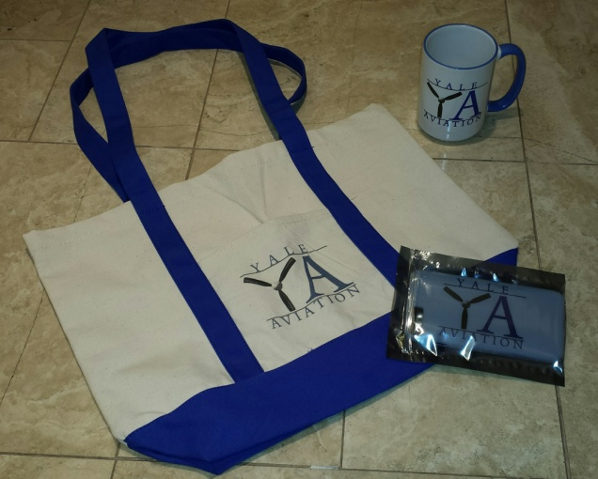
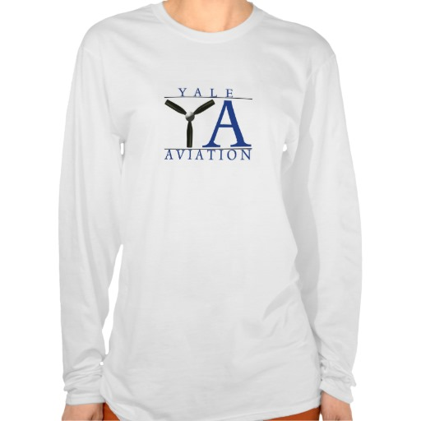
What you order from these locations will be delivered directly to you, PLUS a portion of the sales will come back to the club.
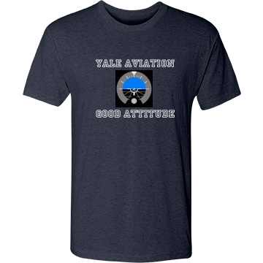
Contact Laura Baldwin (lfbaldwin@aol.com ) if you have any questions or have ideas for additional merchandise!

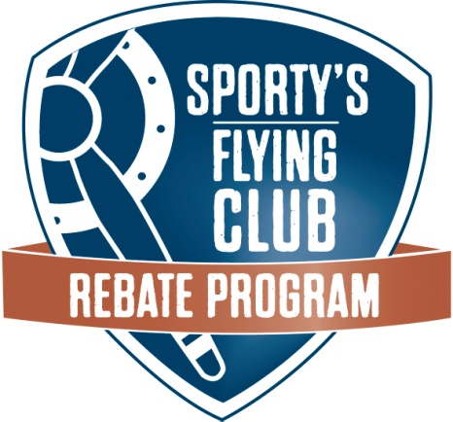
We’re taking part in Sporty’s Flying Club Rebate Program which means we will receive cash back for our club on all your purchases from Sporty’s. Every time you make a regular purchase at Sporty’s – either online, at 800.SPORTYS, or in their store – we will receive a 5% cash rebate, using your email to link these purchases to our club.
Of course, this program is a great way for Sporty’s to steer business their way, but we have an opportunity to also reap the benefit. With your participation, this will be a win-win for all of us. Go to sportys.com or call 800-SPORTYS – no special code needed.
If you have a friend or family member who buys presents for you, be sure to let me know so I can get them added to our club list. Anyone who is NOT on that list will not get us our rebate, even if they are buying for someone on the list!!

SIMULATOR -
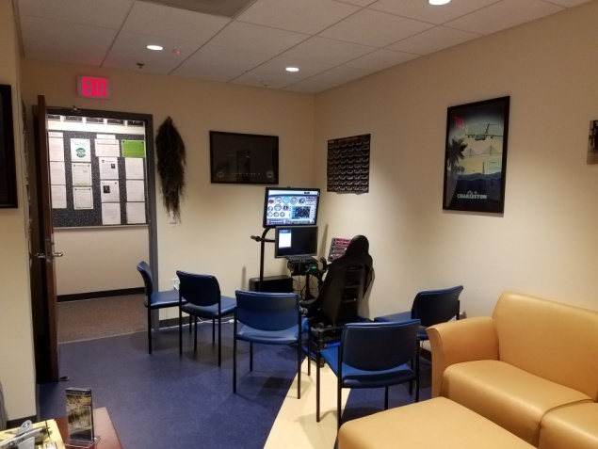
The simulator has been moved to a new, improved, and easily accessible location! It now lives in the “Hangar” of the Yale AFROTC suite. The address for the simulator is 55 Whitney Avenue, Suite 450, 4th floor.
For those with Yale Net IDs that would like to gain access to the building and the simulator, send an email to Micah@yale.edu with your name and Yale Net ID. He will work with the AFROTC team to give you access.
If you do not have a Yale Net ID, you will need to gain access to the sim through Charlie Skelton or another club member with access. YA has priority over use of the sim, so feel free to use it even if cadets are there when you arrive.

~~~~~~~~~~~~~~~~~~~~~~~~~~~~~~~~~~~~~~~~~~~~~~~~~~~~~~~~~~~~~~~~~~~~~~~~~~~~~~~~~~~~~~~~~~~~~~~~~~~~~~~~~~~~~~~~~~~~~~~~~~~~~~~~~~~~~~~~~~~~~~~~~~~~~~~~~~~~~~~~~~~
The Yale Aviation Newsletter goes out to the membership on the 15th of every month. Please let me know if you have any news, suggestions, or comments:

YASecretary@aol.com Laura Baldwin, Secretary
~~~~~~~~~~~~~~~~~~~~~~~~~~~~~~~~~~~~~~~~~~~~~~~~~~~~~~~~~~~~~~~~~~~~~~~~~~~~~~~~~~~~~~~~~~~~~~~~~~~~~~~~~~~~~~~~~~~~~~~~~~~~~~~~~~~~~~~~~~~~~~~~~~~~~~~~~~~~~~~~~~~~

