YALE AVIATION NEWSLETTER
May 2018
UPCOMING EVENTS –
- The FAA will discontinue the Direct User Access Terminal Service (DUATS II) Program, effective May 16, 2018. Internet services, including access to weather and aeronautical information, flight plan filing and automated services will remain available at no charge to pilots at www.1800wxbrief.com. To continue to receive free services, users are encouraged to register with www.1800wxbrief.com. The FAA will work with current DUATS II providers on transition activities, including conducting pilot outreach, establishing commercial interfaces, and providing user migration assistance.
- May 17, 5:30 pm – Mory’s Hangar Talk: Ken Gray, FBI retired, lecturer, Henry C. Lee College of Criminal Justice and Forensic Sciences, University of New Haven, will be our guest to speak on drones:
“We are entering into a new period of aviation; the era of unmanned aerial vehicles, more commonly referred to as drones. While military drones and hobby level drones have been with us for several years, the commercial use of drones is upon us. This emerging technology offers innovations in aerial inspections and surveillance, package deliveries, aerial photography, and even commercial transportation. There is a dark side of this technology. Drones can also be used as a weapon.”
This talk will explore some of the techniques currently developed to counter the threat of terrorism using drones. RSVP by TODAY to John DeCarlo (JDeCarlo@newhaven.edu).
- May 19 – KMMK Fly-In & Public Safety Festival, 9 – 3 pm. RESCHEDULED from last weekend. The goal is to spotlight the Meriden Markham Municipal Airport and to showcase aircraft and Public Safety providers, both local and state. This should be an educational and fun day for all. For more information go to: http://www.meridenmarkham.com/flyin.htm

PILOTS…
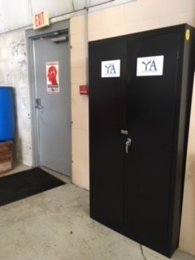
Looks what’s here! A storage locker for Yale Aviation, located in the hangar at Robinson, next to the back wall door.
Items stored here include books to be lent, donated t-shirts, donated avionics, spare parts and cushions. There is a basic 4-digit luggage lock currently in place whose combination is the digital version of YALE: 9253.

Cloud Crowd Meeting
Jake White, Mirai Hashimoto, and Laura Baldwin met to try out something new. We used a scenario developed by Jake to practice using the GTN650 to plan and fly an IFR trip. We learned a lot. Next time we are going to incorporate it with the simulator….

Those of you who’ve accumulated more hours than you might likely fly please consider donating to the club – it is tax deductible!! Help keep Yale Aviation alive in the future as it was for you!

… & PLANES
~~~~~~~~~~~~~~~~~~~~~~~ !!!!!BIRD NESTS!!!!! ~~~~~~~~~~~~~~~~~~~~~~~
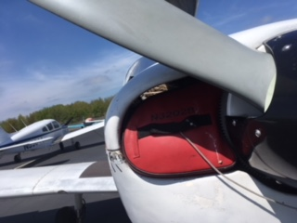
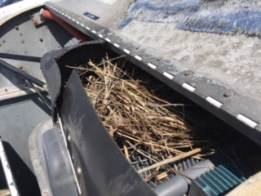
This nest was found on top of the engine in 32028 during preflight. The nose plugs weren’t snuggly in place (see below), and the birds took advantage. It does NOT take the critters long. PLEASE be careful both before and after your flight, and ALWAYS use noseplugs at this time of year!!!!

ADS-B IN OUR AIRPLANES
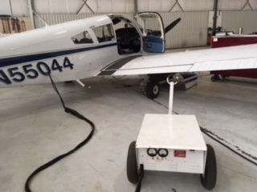
N55044 received its ADS-B in January, and members are beginning to fly using this new equipment. Those flying 55044 need to get additional training to become practiced in using the new GTN650, especially before IFR flight!
For VFR flight: You will need some basic training, which can be given by a YA CFI during a 90-day, Flight Review or basic YA checkout. We trust that our members will use good judgment to be sure they are adequately familiar with this new technology for simple VFR flying.
For IFR flight: We will be requiring a sign-off by one of our YA CFIs to ensure that all the ins & outs of flight planning, approach loading, and validity of use of the GPS as a navigational tool are practiced and understood.
Below are some online resources so you can use to become familiar with the equipment:
- GTN 650 Features Overview (Aircraft Spruce) -- https://www.youtube.com/watch?v=VPke-jhp_8o

- GTN Trainer App -- https://itunes.apple.com/us/app/garmin-gtn-trainer/id479670018?mt=8&ign-mpt=uo%3D8

In addition, Robinson has an external power source one can use to power up our GTN for practice. We have manuals and reference guides on our website, and plan on formulating a syllabus for both VFR and IFR use of this equipment. The checklist for 55044 is also being updated to include checks that should be made as the GPS unit powers up.

Any comments or questions, please contact Charlie Skelton, Laura Baldwin, or Akihiro Hashimoto.

HOW WE TREAT OUR AIRPLANES! When you arrive at the airport, you should expect the aircraft to be in the following condition:
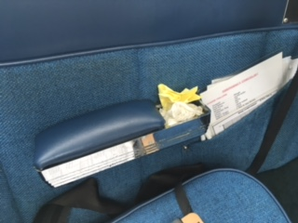
    - TAKE OUT THE TRASH! Please be sure any spare paper, charts, etc are removed after your flight.
    - CAREFUL WITH THE BRAKES!! We have had 5 tire changes in the last year, with “flat spots” often seen on the tires of both airplanes. This is most commonly caused by landing while holding the brakes or braking too hard to make the first turn off the runway. PLEASE, be kind to the tires, and watch how you are using the brakes.
    - Tied down securely, with proper knots, taut lines, and no spare length of rope that can whip around in the wind. The picture below is NOT acceptable tie-down!!!! Please ask if you need a demo or some practice in this vital area for airplane security.
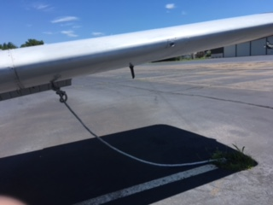
    - Gust lock is in position, window closed, aircraft locked, COVER ON!
    - ALL instruments turned off –particularly important for doing the hot mag check at shut-down, since an unexpected electrical surge could fry delicate avionics equipment left on!
    - For 044, the seat-back covers (those “caps” that slip over the top of the seat to prevent wear on the fabric) should be in place!
If the aircraft is not up to this standard, please let chief pilot Charlie Skelton (203-640-3580) know so he can improve matters. Be sure to leave our airplanes secure and clean – just like YOU would like to find them!

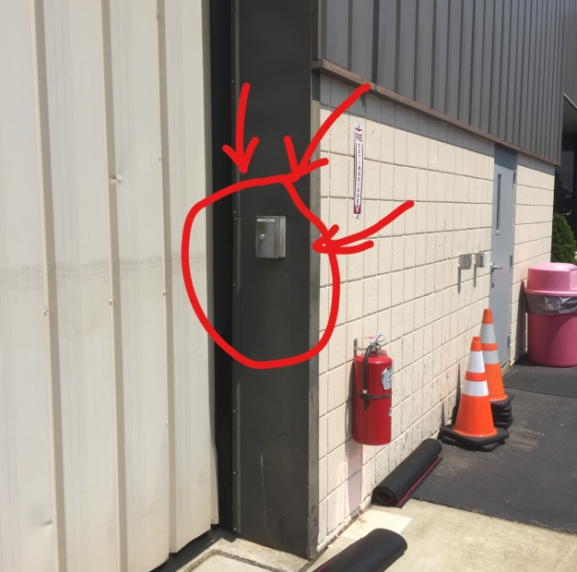
We like to encourage our members to take the airplanes and make use of them, but PLEASE remember that if you find you need to have fuel for the planes or take them in or out of the hangars afterhours, this will result in a CALLOUT FEE of $150 that will be charged to Yale Aviation and passed on to you. The easiest way to avoid these fees – and work well with the kind line folks at Robinson – is FOR YOU to let the Robinson front desk know well ahead of time if you need fuel or wish to use the airplanes early or late. Please be as considerate as you can of their time and efforts.
In addition, there is a drop box to the right of the doors to the hangar nearest the FBO entrance from the ramp. This is where you can leave airplane keys if you return to the airport after Robinson has closed. PLEASE be considerate of your fellow aviators.
Any questions? Please give Charlie Skelton a call and he can go over both dropbox use and what constitutes a callout!
32028 is AOK.
55044 is also AOK.
ALSO NOTE:
- We must be vigilant at keeping water out. Please, always use the airplane cover when you know it will be raining, as this will really help! If the weather is sunny, then having the cover off is preferred. When in doubt, ask Charlie!
- Remember: ONLY remove the cowling when you have at least two (2) people. Scrapes and chips can easily occur, and this is most probable when you try to remove the cowling with one person only!

AVIATION EDUCATION & NEWS –
"KMMK Fly In and Public Safety Festival"
Topic: Flying Low and Slow Up the East Coast.
On Saturday, May 19, 2018 at 10:30 Eastern Daylight Time
Location:
MERIDEN-MARKHAM AIRPORT
213 Evansville Av
Meriden, CT 06451
Select Number:
AFS083215
Description:
Cross-country flying is an amazing experience but it involves careful planning regarding the aircraft, weather, route, and pilot. Join CFI, tailwheel instructor, and FAASTeam Representative Jason T. Archer...to hear what it was like to fly 1600 miles in a 1941 Piper Cub from the Florida Keys to New England, in the middle of winter. As the adventure is told (including incredible aerial footage) we’ll look at the lessons learned in regards to making sure your aircraft is capable, long-range weather planning, fuel management, back to basics flight planning, navigation, and how to plan for and deal with the unexpected. Please join us for this unique and exciting presentation for pilots and non-pilots alike. Discover why the Piper Cub might just be the best cross-country flying machine ever made!
To view further details and registration information for this seminar, click here.
The sponsor for this seminar is: FAASTeam, EA-63 FSDO
The FAA Safety Team (FAASTeam) is committed to providing equal access to this meeting/event for all participants. If you need alternative formats or services because of a disability, please communicate your request as soon as possible with the person in the 'Contact Information' area of the meeting/event notice. Note that two weeks is usually required to arrange services.
The following credit(s) are available for the WINGS/AMT Programs:
n/a
Click here to view the WINGS help page

"Weather Risk Assessment"
Topic: Gain Confidence in Weather Using Great Weather Detection Tools
On Tuesday, May 22, 2018 at 13:30 Pacific Daylight Time (14:30 MDT, 15:30 CDT, 16:30 EDT, 10:30 HST, 12:30 AKDT, 13:30 Arizona, 20:30 GMT)
Select Number:
WP0183087

Description:
In this 90 minute webinar (plus Q&A) Delia will demonstrate her method to clarify and add certainty to often conflicting weather information.
• The top resource for assessing potential turbulence or mountain wave.
• The most unreliable site that most pilots depend on (and what to use instead)
• How to determine if icing is a factor
• Recognizing LLWS even when it's not forecast.
Click here to register today
To view further details and registration information for this webinar, click here.
The sponsor for this seminar is: FAASTeam
The following credit(s) are available for the WINGS/AMT Programs:
Advanced Knowledge 1 - 1 Credit

"Gliding - For the Airplane Pilot"
Topic: Glide speeds and factors, used by glider pilots, but also important to airplane pilots.
On Tuesday, May 29, 2018 at 18:30 Eastern Daylight Time (15:30 PDT, 16:30 MDT, 17:30 CDT, 12:30 HST, 14:30 AKDT, 15:30 Arizona, 22:30 GMT)
Select Number:
EA6183136
Description:
Become a better airplane pilot by learning some of the “secrets” of sailplane/glider pilots. An expanded version of the GAJSC Topic of the Month on “Best Glide”. Learn about not only Best Glide and Minimum Sink, but learn about Speed-To-Fly. Learn how to adjust your flying speed for a given condition. Do you know what your real glide ratio is? Do you really think you can make it to that field? Join us to learn more and how to soar on your gliding knowledge.
To view further details and registration information for this webinar, click here.
The sponsor for this seminar is: FAASTeam
The following credit(s) are available for the WINGS/AMT Programs:
Basic Knowledge 3 - 1 Credit

PODCASTS & APPS & GADGETS– Please send me your favorite app, tech toy, video or podcast suggestion to share!
Just a bit of fun: flying cars, anyone?? https://www.youtube.com/watch?v=VRZNLBL7Px4

TWEED NEWS -
TSA Badges – Need a new or renewed badge?? Remember that for the procedure you must have a completed application signed by our TSA signatory, Laura Baldwin (203-966-8499, lfbaldwin@aol.com ). Once that is done, you call KATHY GRANT (203-466-8833 ext 109) over at WEST ramp to make an appointment to take training, have your fingerprints taken, pay your fee of $30 (cash or check made out to “HVN”) and have your new badge issued. Renewals are $15, which we all need to do every calendar year. Be sure to have your old badge plus two forms of government issued ID, and at least one NEEDS TO BE PASSPORT, SOCIAL SECURITY CARD OR BIRTH CERTIFICATE. Tweed is becoming quite serious about everyone having and using their security badge – pilots without badges will be escorted from the airport and will not be able to fly!!! Do not be that pilot – get your KHVN badge NOW!!!

ONLINE -
Yale Aviation is on Facebook - be sure to post photos, ask questions of fellow pilots, encourage those who are working their way through ratings and exams, or see if you can organize a passenger on your next flight. We have opened this group so that your friends (and prospective members?) can see what we are all about.
Remember pictures can also be posted on our Yale Aviation website at www.YaleAviation.org. Tom Sobocinski, our Webmaster, has updated the site to include a gallery of names and faces, current Newsletters and the full 12-serie Yale Aviation, Inc History by Hank Galpin. Check it out!!! (Suggestions for further revisions welcome)
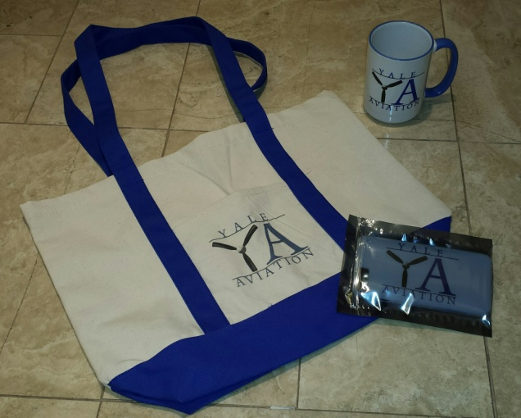
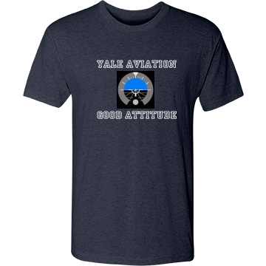
IF YOU DON’T LIKE YOUR PICTURE ONLINE, PLEASE SEND ME A BETTER ONE!

YA MERCHANDISE! Check out our two online “storefronts” for purchasing YA-logoed merchandise! One is at located at Customized Girl (http://www.customizedgirl.com/s/yaleaviationmerch) and one at Zazzle (http://www.zazzle.com/yaleaviationstore).
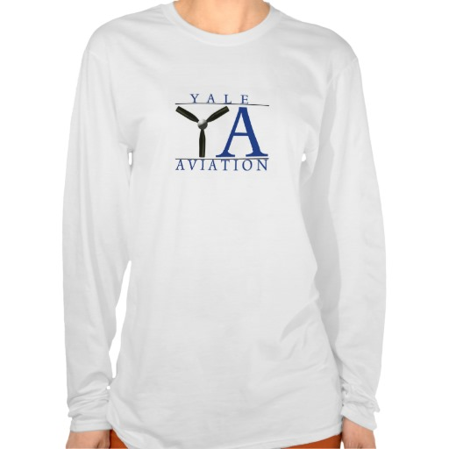
What you order from these locations will be delivered directly to you, PLUS a portion of the sales will come back to the club.
Contact Laura Baldwin (lfbaldwin@aol.com ) if you have any questions or have ideas for additional merchandise!

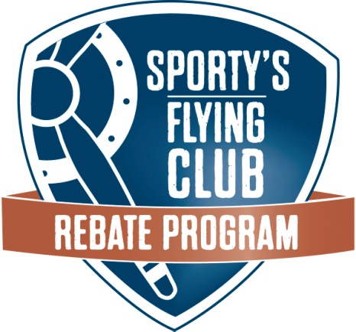
We’re taking part in Sporty’s Flying Club Rebate Program which means we will receive cash back for our club on all your purchases from Sporty’s. Every time you make a regular purchase at Sporty’s – either online, at 800.SPORTYS, or in their store – we will receive a 5% cash rebate, using your email to link these purchases to our club.
Of course, this program is a great way for Sporty’s to steer business their way, but we have an opportunity to also reap the benefit. With your participation, this will be a win-win for all of us. Go to sportys.com or call 800-SPORTYS – no special code needed.
If you have a friend or family member who buys presents for you, be sure to let me know so I can get them added to our club list. Anyone who is NOT on that list will not get us our rebate, even if they are buying for someone on the list!!
SIMULATOR -
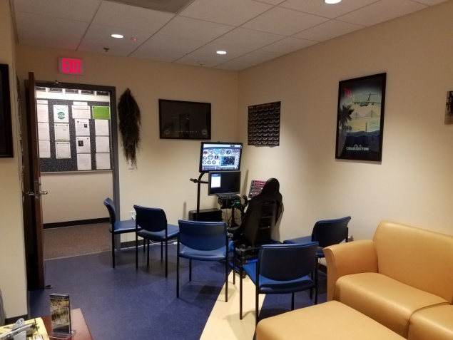
The simulator has been moved to a new, improved, and easily accessible location! It now lives in the “Hangar” of the Yale AFROTC suite. The address for the simulator is 55 Whitney Avenue, Suite 450, 4th floor.
Here are a few basic instructions on the simulator’s use:
- Turn on the desktop, found on the floor under the screen.
- Using the keyboard, right-click on the “Flight Sim” icon.
- Once the program starts up, you will need to reset it (it starts with an F#% at full throttles at Islip).
- From the top left of the screen, click on “load” for menus, for example “KHVN C172”.
- Click on the “Views” menu to alter what you see on the screen:
  - Landing (no switches at the bottom, so maximum outside view)
  - IFR (only the panel – no outside view)
  - Normal (some switches along the bottom of the screen, some outside view)
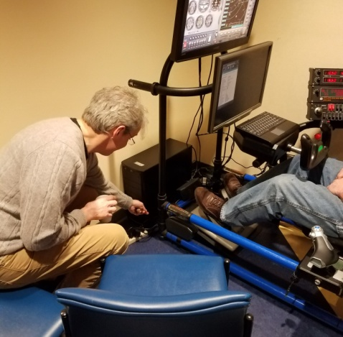
- To create a special scenario, on the “World” menu:
  - Click on “airport” to choose your airport
  - Click “Map” to choose a spot via latitude and longitude
  - Click on “Weather” to choose the conditions you want to fly in (rain, wind speed, direction, visibility, etc.
- To close down the sim, click “exit” on flight simulator, then do a normal Windows 7 shutdown.

Tips:
- You will need to fly by the numbers, as the sim has minimal feel in the yoke.
- Be sure to use trim!
- Keep your toes on the bottom of the rudder pedals to prevent applying the brakes by mistake.
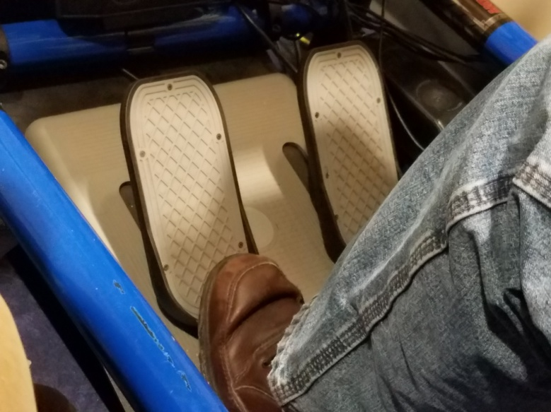
- Using “Num Lock”, then tapping SHIFT 5 will change the view from IFR to Landing.
- The “hat” on the left handle of the yoke will shift your screen’s view around the airplane, from front, to side, to back.
For those with Yale Net IDs that would like to gain access to the building and the simulator, send an email to Micah@yale.edu with your name and Yale Net ID. He will work with the AFROTC team to give you access.
If you do not have a Yale Net ID, you will need to gain access to the sim through Charlie Skelton or another club member with access. YA has priority over use of the sim, so feel free to use it even if cadets are there when you arrive.
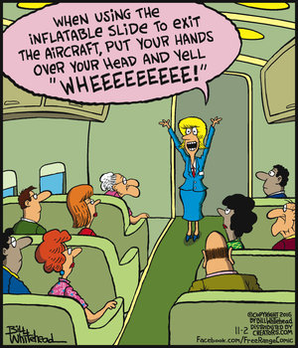

~~~~~~~~~~~~~~~~~~~~~~~~~~~~~~~~~~~~~~~~~~~~~~~~~~~~~~~~~~~~~~~~~~~~~~~~~~~~~~~~~~~~~~~~~~~~~~~~~~~~~~~~~~~~~~~~~~~~~~~~~~~~~~~~~~~~~~~~~~~~~~~~~~~~~~~~~~~~~~~~~~~
The Yale Aviation Newsletter goes out to the membership on the 15th of every month. Please let me know if you have any news, suggestions, or comments:

YASecretary@aol.com Laura Baldwin, Secretary
~~~~~~~~~~~~~~~~~~~~~~~~~~~~~~~~~~~~~~~~~~~~~~~~~~~~~~~~~~~~~~~~~~~~~~~~~~~~~~~~~~~~~~~~~~~~~~~~~~~~~~~~~~~~~~~~~~~~~~~~~~~~~~~~~~~~~~~~~~~~~~~~~~~~~~~~~~~~~~~~~~~~

